Technical Memorandum BCWA

Date: March 24, 2020
To: Bear Creek Watershed Association
From: Russell N. Clayshulte, Manager

Re: BCWA TM 2019.10 Fishery

Contents
2019 Survey Sites and Data 1
2019 Comparison of Fish Surveys 3
2019 Fishery Graphs 3
2014-2019 Comparison of Fishery Summaries 4
Long-Term Fishery Trends 5
Brown Trout Station Trends 6

Figure 1 Fish Collection Method 2
Figure 2 2019 Total Number of Fish per Mile 3
Figure 3 2019 Total Number of Fish per Acre 4
Figure 4 2019 Total Pounds of Fish per Acre 4
Figure 5 Comparison of Trout per Mile from 2014 to 2019 4
Figure 6 Total Trout Pounds per Acre from 1988-2019 5
Figure 7 Segment 1e Total Trout per Acre from 1988-2019 5
Figure 8 Average Trout per Acre after 2013 Flooding Event 5
Figure 9 Average Brown Trout Trends 6
Figure 10 Dedisse Park Trend 6
Figure 11 Bear Creek Cabins Trend 6
Figure 12 O’Fallon Trend 7
Figure 13 Lair O’ Bear Trend 7
Figure 14 Morrison Trend 7
Figure 15 Golden Willow 8

Table 1 2019 Bear Creek Watershed Fishery Survey Sites 2
Table 2 2019 Fishery Data Summary 2
Table 3 2016 to 2019 Fishery Summary Comparison 3

2019 Survey Sites and Data
The Colorado Parks and Wildlife (“CPW”) collects aquatic data from both internal sources and a variety of external governmental and non-governmental agencies. CPW provides this data, upon request, solely as a public service. In September 10 to 12, 2019, personnel from the CPW conducted fishery surveys on Bear Creek. The fishery data is graphically summarized in this technical memorandum as processed by the BCWA. CPW makes no warranty, representation, or guarantee as to the content, accuracy or completeness of any of the data provided.

Fishery surveys were done at 6 sites (Table 1). No data was collected from the Evergreen downtown station (Little Bear) or the Idledale station. Table 2 is the 2019 fishery data (only Brown Trout and Rainbow Trout) supplied to the BCWA for use in its watershed management program and reporting to the Water Quality Control Commission as part of the BCWA annual report. This data may not be re-published without approval of the BCWA. Table 3 compares the 2016 to 2019 fishery summaries.
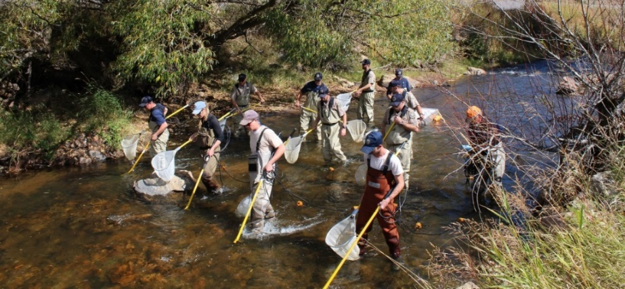
Figure 1 Fish Collection Method
Table 1 2019 Bear Creek Watershed Fishery Survey Sites
Station Location | Station Length | Avg Width | Survey Date | Survey ID
Morrison Park Just BLW Bridge | 476 | 30 | 9/10/2019 | 60867
Lair O Bear Picnic Areas (#13) | 491 | 29 | 9/10/2019 | 60868
O’Fallon Park Picnic Areas (#14) | 372 | 28 | 9/11/2019 | 60869
BLW Bear Creek Cabins (#1) | 441 | 32 | 9/11/2019 | 60967
Dedisse Park (Keys on the Green) | 368 | 33 | 9/12/2019 | 60870
Just above Golden Willow Rd. | 342 | 23 | 9/12/2019 | 60871

Table 2 2019 Fishery Data Summary
Station | Width (ft) | Length (ft) | Species | 2019 No/Mile Total | 2019 No/Acre Total | 2019 lb/Acre Total
Golden Willow | 23 | 342 | Brown | 1491 | 535 | 119
 |  |  | Rainbow | 0 | 0 | 0
 |  |  | Total | 1491 | 535 | 119
Dedisse Park | 33 | 368 | Brown | 1803 | 451 | 62
 |  |  | Rainbow | 174 | 43 | 6
 |  |  | Total | 1976 | 494 | 68
Bear Creek Cabins | 32 | 441 | Brown | 2682 | 691 | 114
 |  |  | Rainbow | 615 | 159 | 26
 |  |  | Total | 3297 | 850 | 140
O'Fallon Park | 28 | 372 | Brown | 3280 | 967 | 148
 |  |  | Rainbow | 102 | 30 | 5
 |  |  | Total | 3383 | 997 | 152
Lair O' the Bear | 29 | 491 | Brown | 2334 | 664 | 146
 |  |  | Rainbow | 98 | 28 | 6
 |  |  | Total | 2432 | 692 | 152
Morrison West | 30 | 476 | Brown | 1877 | 516 | 112
 |  |  | Rainbow | 33 | 9 | 2
 |  |  | Total | 1910 | 525 | 114
No fish surveys at Evergreen Little Bear Site or Idledale Site
No Rainbow Trout found at the Golden Willow Site

2019 Comparison of Fish Surveys

Table 3 2016 to 2019 Fishery Summary Comparison
Station | Width (ft) | Species | 2016 |  |  | 2017 |  |  | 2019
 |  |  | No/Mile Total | No/Acre Total | lb/Acre Total | No/Mile Total | No/Acre Total | lb/Acre Total | No/Mile Total | No/Acre Total | lb/Acre Total
Golden Willow | 23 | Brown | 1543 | 553 | 83 | 1,551 | 556 | 107 | 1491 | 535 | 119
 |  | Rainbow | 15 | 6 | 1 | - | - | - | 0 | 0 | 0
 |  | TOTAL | 1558 | 559 | 84 | 1,551 | 556 | 107 | 1491 | 535 | 119
Dedisse Park | 33 | Brown | 2583 | 646 | 75 | 2,666 | 666 | 80 | 1803 | 451 | 62
 |  | Rainbow | 158 | 39 | 5 | 184 | 46 | 5 | 174 | 43 | 6
 |  | TOTAL | 2740 | 685 | 79 | 2,849 | 712 | 85 | 1976 | 494 | 68
Evergreen | 34 | Brown | 1427 | 346 | 103 | 1,932 | 469 | 147
 |  | Rainbow | 399 | 97 | 29 | 726 | 176 | 55
 |  | TOTAL | 1827 | 443 | 131 | 2,658 | 645 | 202
Bear Creek Cabins | 32 | Brown | 1126 | 290 | 77 |  |  |  | 2682 | 691 | 114
 |  | Rainbow | 263 | 68 | 18 |  |  |  | 615 | 159 | 26
 |  | TOTAL | 1389 | 358 | 95 |  |  |  | 3297 | 850 | 140
O'Fallon Park | 28 | Brown | 909 | 268 | 54 | 2,364 | 697 | 122 | 3280 | 967 | 148
 |  | Rainbow | 57 | 17 | 3 | 57 | 17 | 3 | 102 | 30 | 5
 |  | TOTAL | 966 | 285 | 57 | 2,421 | 713 | 125 | 3383 | 997 | 152
Lair O' Bear | 29 | Brown | 1293 | 368 | 94 | 1,363 | 388 | 95 | 2334 | 664 | 146
 |  | Rainbow | 86 | 24 | 6 | 176 | 50 | 12 | 98 | 28 | 6
 |  | TOTAL | 1379 | 392 | 101 | 1,538 | 438 | 107 | 2432 | 692 | 152
Idledale | 25 | Brown |  |  |  | 2,130 | 703 | 203
 |  | Rainbow |  |  |  | 151 | 50 | 14
 |  | TOTAL |  |  |  | 2,281 | 753 | 217
Morrison | 30 | Brown | 1353 | 372 | 99 | 2,163 | 595 | 144 | 1877 | 516 | 112
 |  | Rainbow | 91 | 25 | 7 | 177 | 49 | 12 | 33 | 9 | 2
 |  | TOTAL | 1443 | 397 | 105 | 2,341 | 644 | 156 | 1910 | 525 | 114

2019 Fishery Graphs

Figure 2 2019 Total Number of Fish per Mile

Figure 3 2019 Total Number of Fish per Acre

Figure 4 2019 Total Pounds of Fish per Acre

2014-2019 Comparison of Fishery Summaries
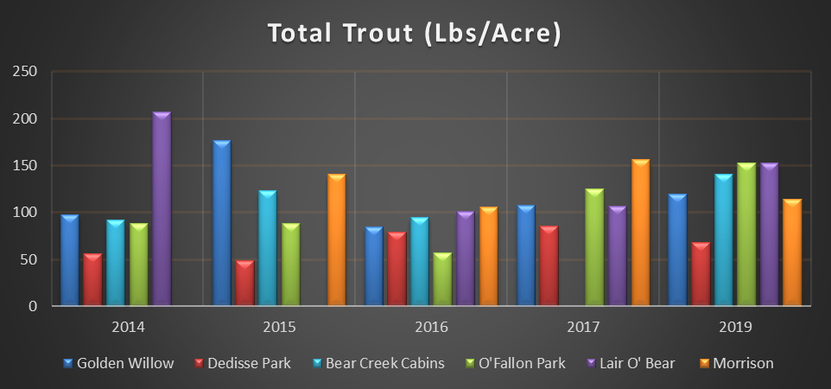
Figure 5 Comparison of Trout per Mile from 2014 to 2019

Long-Term Fishery Trends

Figure 6 Total Trout Pounds per Acre from 1988-2019

Figure 7 Segment 1e Total Trout per Acre from 1988-2019

Figure 8 Average Trout per Acre after 2013 Flooding Event

Figure 9 Average Brown Trout Trends

Brown Trout Station Trends

Figure 10 Dedisse Park Trend

Figure 11 Bear Creek Cabins Trend

Figure 12 O’Fallon Trend

Figure 13 Lair O’ Bear Trend

Figure 14 Morrison Trend

Figure 15 Golden Willow

